**APPENDIX D**

**CATALOG**

**CATALOG FOR BOILER**

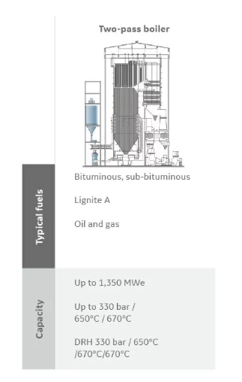

**CATALOG FOR STEAM TURBINE**

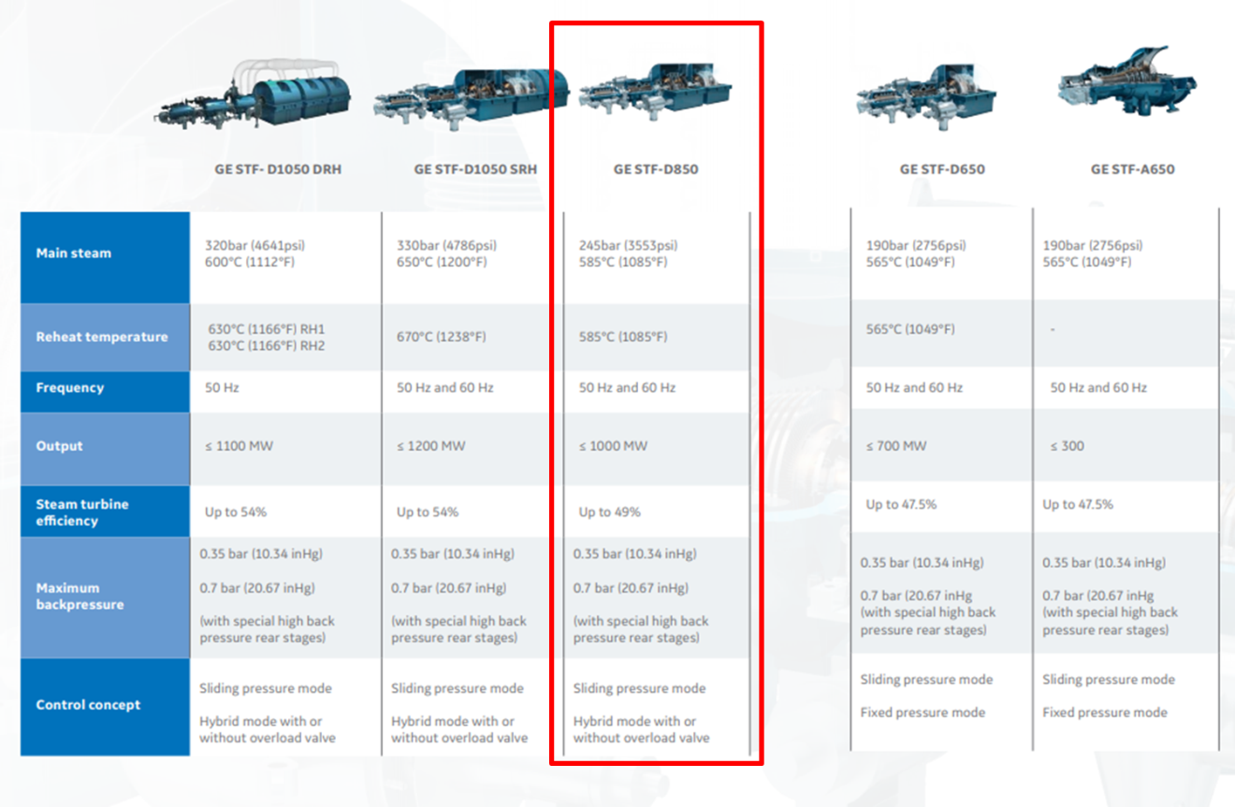

**CATALOG FOR CONDENSER**

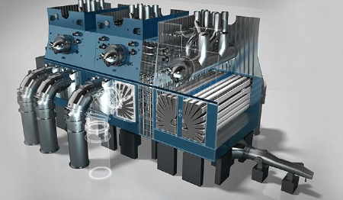

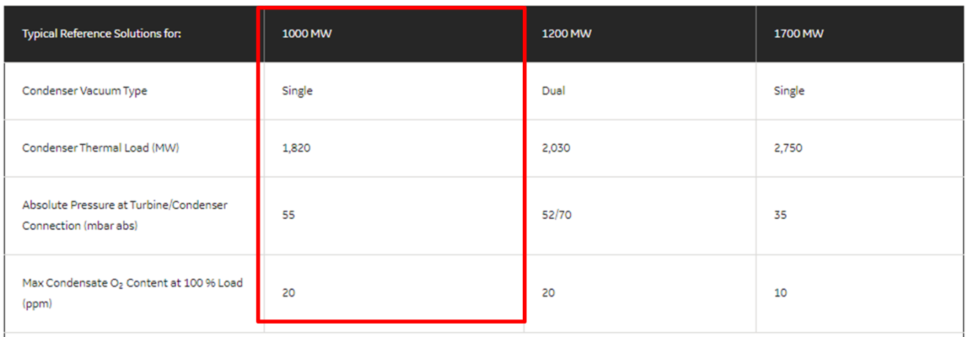

**CATALOG FOR PUMPS**

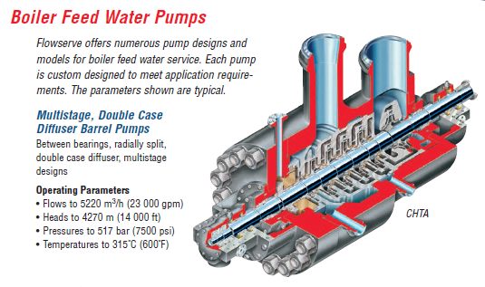

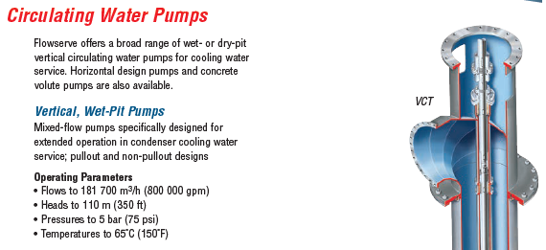

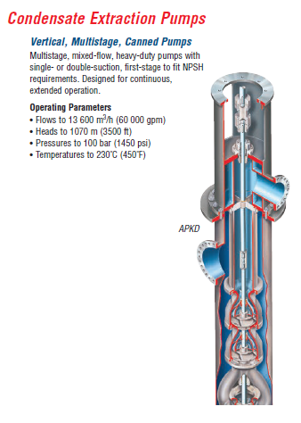

**CATALOG FOR CLOSED FEEDWATER HEATER**

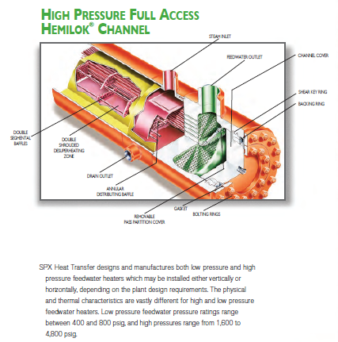

**CATALOG FOR DEAERATOR**

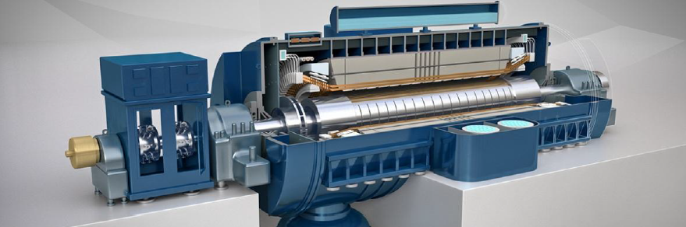

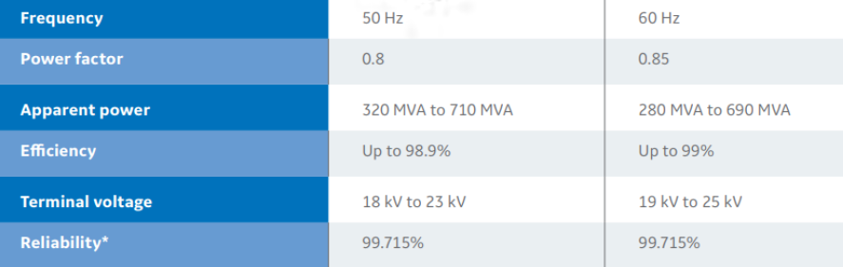

**CATALOG FOR STEAM TRAP**

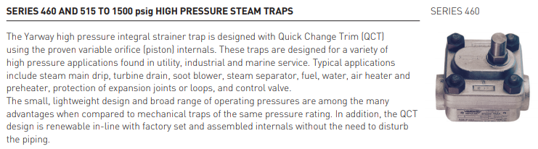

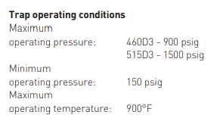

**CATALOG FOR GENERATOR**

